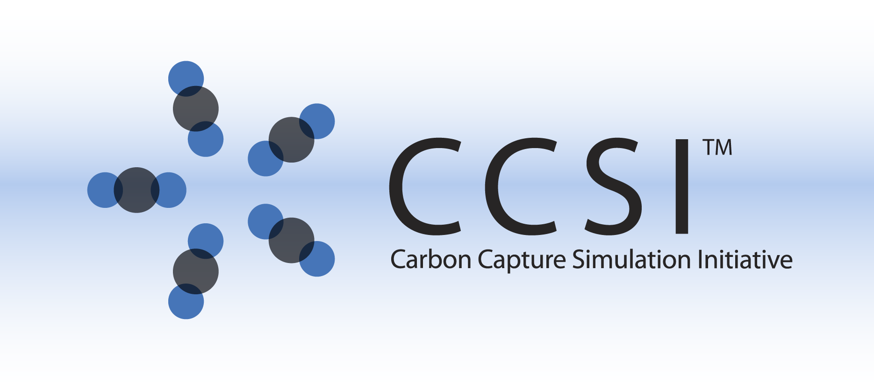

SUBGRID MODELS FOR DRAG IN

3D GAS-PARTICLE FLOWS

USER MANUAL

Version 2.0.0

March, 2018

William A. Lane1, Avik Sarkar2, Xin Sun2, Emily M. Ryan1, Sunkaran Sundaresan3

1Boston University, Boston, MA

2Pacific Northwest National Laboratory, Richland, WA

3Princeton University, Princeton, NJ

Copyright (c) 2012 - 2018

**Copyright Notice**

Filtered Models for Drag in 3D Gas-Particle Flows was produced under the DOE Carbon Capture Simulation Initiative (CCSI), and is copyright (c) 2012 - 2018 by the software owners: Oak Ridge Institute for Science and Education (ORISE), Los Alamos National Security, LLC., Lawrence Livermore National Security, LLC., The Regents of the University of California, through Lawrence Berkeley National Laboratory, Battelle Memorial Institute, Pacific Northwest Division through Pacific Northwest National Laboratory, Carnegie Mellon University, West Virginia University, Boston University, the Trustees of Princeton University, The University of Texas at Austin, URS Energy & Construction, Inc., et al.. All rights reserved.

NOTICE. This Software was developed under funding from the U.S. Department of Energy and the U.S. Government consequently retains certain rights. As such, the U.S. Government has been granted for itself and others acting on its behalf a paid-up, nonexclusive, irrevocable, worldwide license in the Software to reproduce, distribute copies to the public, prepare derivative works, and perform publicly and display publicly, and to permit other to do so.

**License Agreement**

Filtered Models for Drag in 3D Gas-Particle Flows Copyright (c) 2012 - 2018, by the software owners: Oak Ridge Institute for Science and Education (ORISE), Los Alamos National Security, LLC., Lawrence Livermore National Security, LLC., The Regents of the University of California, through Lawrence Berkeley National Laboratory, Battelle Memorial Institute, Pacific Northwest Division through Pacific Northwest National Laboratory, Carnegie Mellon University, West Virginia University, Boston University, the Trustees of Princeton University, The University of Texas at Austin, URS Energy & Construction, Inc., et al. All rights reserved.

Redistribution and use in source and binary forms, with or without modification, are permitted provided that the following conditions are met:

1. Redistributions of source code must retain the above copyright notice, this list of conditions and the following disclaimer.
2. Redistributions in binary form must reproduce the above copyright notice, this list of conditions and the following disclaimer in the documentation and/or other materials provided with the distribution.
3. Neither the name of the Carbon Capture Simulation Initiative, U.S. Dept. of Energy, the National Energy Technology Laboratory, Oak Ridge Institute for Science and Education (ORISE), Los Alamos National Security, LLC., Lawrence Livermore National Security, LLC., the University of California, Lawrence Berkeley National Laboratory, Battelle Memorial Institute, Pacific Northwest National Laboratory, Carnegie Mellon University, West Virginia University, Boston University, the Trustees of Princeton University, the University of Texas at Austin, URS Energy & Construction, Inc., nor the names of its contributors may be used to endorse or promote products derived from this software without specific prior written permission.

THIS SOFTWARE IS PROVIDED BY THE COPYRIGHT HOLDERS AND CONTRIBUTORS "AS IS" AND ANY EXPRESS OR IMPLIED WARRANTIES, INCLUDING, BUT NOT LIMITED TO, THE IMPLIED WARRANTIES OF MERCHANTABILITY AND FITNESS FOR A PARTICULAR PURPOSE ARE DISCLAIMED. IN NO EVENT SHALL THE COPYRIGHT OWNER OR CONTRIBUTORS BE LIABLE FOR ANY DIRECT, INDIRECT, INCIDENTAL, SPECIAL, EXEMPLARY, OR CONSEQUENTIAL DAMAGES (INCLUDING, BUT NOT LIMITED TO, PROCUREMENT OF SUBSTITUTE GOODS OR SERVICES; LOSS OF USE, DATA, OR PROFITS; OR BUSINESS INTERRUPTION) HOWEVER CAUSED AND ON ANY THEORY OF LIABILITY, WHETHER IN CONTRACT, STRICT LIABILITY, OR TORT (INCLUDING NEGLIGENCE OR OTHERWISE) ARISING IN ANY WAY OUT OF THE USE OF THIS SOFTWARE, EVEN IF ADVISED OF THE POSSIBILITY OF SUCH DAMAGE.

You are under no obligation whatsoever to provide any bug fixes, patches, or upgrades to the features, functionality or performance of the source code ("Enhancements") to anyone; however, if you choose to make your Enhancements available either publicly, or directly to Lawrence Berkeley National Laboratory, without imposing a separate written license agreement for such Enhancements, then you hereby grant the following license: a non-exclusive, royalty-free perpetual license to install, use, modify, prepare derivative works, incorporate into other computer software, distribute, and sublicense such enhancements or derivative works thereof, in binary and source code form. This material was produced under the DOE Carbon Capture Simulation.

**Revision Log**

|  |  |  |
| --- | --- | --- |
| **Version Number** | **Release Date** | **Description** |
| Version 2015.10.0 | 10/31/2015 | Fixed bugs in example files and updated user manual. Will be combined with other filtered models in future release. |
| Version 2015.03.0 | 3/31/2015 | 2015 initial release of package. |
| Version 2.0.0 | 03/31/2018 | Initial Open Source release |

Table of Contents

1. Introduction 1

1.1. Motivating Example 1

2. Installation 2

2.1. System Requirements 2

2.2. Third Party Software 2

2.3. Product Usage 2

3. Example 3

3.1. Geometry 3

3.2. Subgrid Model Settings 3

3.3. Compiling and Running the Simulation 3

4. Usage Information 4

4.1. Support 4

4.2. Restrictions 4

4.3. Next Steps 4

5. Debugging 5

5.1. How to Debug 5

5.2. Known Issues 5

5.3. Reporting Issues 5

6. References 6

List of Figures

Figure 1: Schematics of bubbling fluidized bed example case, where BC denotes boundary conditions and IC denotes initial conditions. The blue IC(2) section represents the bed of solid particles. 3

List of Tables

Table 1: MFIX Keywords for the subgrid models. 2

To obtain support for this package, please send an email to   
[ccsi-support@acceleratecarboncapture.org](mailto:ccsi-support@acceleratecarboncapture.org).

# Introduction

Resolution of small-scale structures such as particle clusters is computationally impractical for large-scale devices, especially when considering 3-dimensional (3D) models. The inability to resolve these small-scale structures results in erroneous simulation predictions.

To enable accurate macroscopic predictions using coarse-grid simulations, subgrid filtered models are developed. These filtered models account for the presence of unresolved physics via constitutive subgrid equations.

This product is an implementation of theses subgrid models for gas-particle interphase drag in 3D flow in MFIX [1,2].

## Motivating Example

Consider a bench-scale fluidized bed unit measuring 0.1 m in diameter by 0.4 m high, with solid-particles with a mean diameter (*dp*) of 100 µm. Typically this system would be discretized into a fine-mesh with grid cells of 10 × *dp* = 1.0 mm, resulting in a system of approximately 3.14 million cells. Alternatively, using a subgrid filtering approach and setting the (coarse) cell size to 50 × *dp* = 0.5 cm results in a system of approximately 25,000 cells, a significant reduction.

# Installation

These products do not require explicit installation; however, the user is required to have MFIX [1,2] made on their system to utilize the models. Note: These products were developed using source files from MFIX release 2015-1. Due to changes in the MFIX software structure, these models are not backwards compatible with previous MFIX releases, please use MFIX 2015-1.

## System Requirements

This product requires MFIX [1-3].

## Third Party Software

Open-source, multi-platform data analysis, and visualization application *ParaView* is recommend for post-processing of the MFIX simulation and can be downloaded from [http://paraview.org](http://paraview.org/). Other similar visualization software (for example, Tecplot, VisIt) can also serve the same purpose.

## Product Usage

It is assumed that the user has built the required MFIX source files and created the entire MFIX directory, as detailed in [3].

To use the filtered models, ensure the following model files (found in model) are in the *local* run directory (in addition to the mfix.dat input file):

drag_gs.f

namelist.inc

run_mod.f

In addition to the standard MFIX keywords, the subgrid filtered models require the following keyword, as shown in Table 1.

Table : MFIX Keywords for the subgrid models.

|  |  |
| --- | --- |
| **SG_3D_HYDRO**  Flag for turning on/off the 3D hydrodynamics (drag) subgrid model. Requires the Wen-Yu drag model. | LOGICAL |

Follow the MFIX instructions [3] to build the MFIX executable in the *local* run directory. Upon successful compilation, an mfix.exe executable is created in the *local* run directory.

# Example

An example input file for a cold-flow fluidized bed unit has been included with the release of this product to demonstrate implementation and use. This section describes the example.

## Geometry

The geometry is based on the motivating example from Section 1.1. The domain measures   
0.1 m in diameter by 0.4 m high. The bed is initialized as full (EP_g = 0.41) at a height of 0.155 m. There is mass-inflow of gas at the base that causes fluidization and a pressure outlet above the freeboard to equalize the pressure. The walls are set to no-slip boundary conditions.

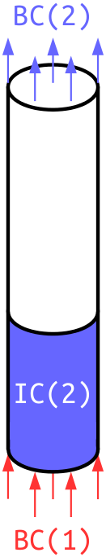

Figure : Schematics of bubbling fluidized bed example case, where BC denotes boundary conditions and IC denotes initial conditions. The blue IC(2) section represents the bed of solid particles.

## Subgrid Model Settings

The subgrid model settings are as follows:

SG_3D_HYDRO = .TRUE.

## Compiling and Running the Simulation

Recompile MFIX (as instructed in Section 2.3) using the following Bash commands:

1. cd example/ # change directory to example/
2. cp –r ../model/* . # copy model files (recursively) to run directory, example/
3. sh $MFIX/model/make_mfix # make MFIX, recompile with local source files, where $MFIX is the location of mfix/
4. mpirun –np $NSLOTS mfix.exe # execute simulation in parallel, where $NSLOTS is the number of processors requested (i.e., NODESI*NODESJ*NODESK)

# Usage Information

## Support

For technical support, send an email to [ccsi-support@acceleratecarboncapture.org](mailto:ccsi-support@acceleratecarboncapture.org) and/or fill out the “Submit Feedback/Request Support” form available on the product distribution page.

## Restrictions

This model does not support multiple solid-phases and requires the use of the Wen-Yu drag model.

## Next Steps

The future release will package the 3D gas-particle subgrid models with the 2D gas-particle-cylinder subgrid models.

# Debugging

Please refer to the following sections for debugging instructions and help contacts.

## How to Debug

The constitutive drag model is implemented in drag_gs.f, while keywords are defined in namelist.f and run_mod.f. Debugging should mainly be within drag_gs.f.

## Known Issues

There are no known issues at this time.

## Reporting Issues

To report an issue, please send an email to [ccsi-support@acceleratecarboncapture.org](mailto:ccsi-support@acceleratecarboncapture.org).

# References

1. M. Syamlal, W. Rogers, T.J. O’Brien, MFIX Documentation Theory Guide. Technical Report, Department of Energy, National Energy Technology Laboratory.
2. Multiphase Flow with Interphase eXchanges (MFIX). Available from <https://mfix.netl.doe.gov/>. Retrieved on October 31, 2015.
3. MFIX User Guide. Available from <https://mfix.netl.doe.gov/>. Retrieved on October 31, 2015.